**Utilizing Deep improved CNN for Brain**

**Tumor Classification Based MRI**

**Abstract**

Brain tumors are among the most severe health conditions, requiring early detection for effective treatment. This project focuses on developing a deep learning model using ResNet-50 to accurately classify brain MRI images into four categories: Glioma, Meningioma, No Tumor, and Pituitary. The dataset was preprocessed using image resizing, normalization, and data augmentation techniques to enhance model performance. The ResNet-50 architecture, with additional spatial pyramid pooling layers, was implemented to capture multi-scale features critical for accurate tumor identification. After extensive model training and hyperparameter tuning, the model achieved an average accuracy of 92.75% and an AUC of 94, indicating strong performance in distinguishing between tumor types. Evaluation metrics such as precision, recall, and F1-score further confirmed the model’s reliability. This project demonstrates a robust and efficient approach for brain tumor classification, with potential applications in clinical diagnostics to support medical professionals in early and accurate tumor identification.

**Keywords**- Brain Tumor Classification, ResNet-50, Convolutional Neural Networks (CNN), MRI Imaging, Deep Learning, Transfer Learning, Medical Image Analysis, Spatial Pyramid Pooling, Hyperparameter Optimization.

**INTRODCUTION**

Brain tumors represent one of the most challenging types of diseases to diagnose and treat due to their complexity, variability in appearance, and potential impact on critical neurological functions. Early and accurate diagnosis is crucial for effective treatment, as timely identification of tumor type and growth patterns can significantly improve patient outcomes. Among the various types of brain tumors, including glioma, meningioma, pituitary adenoma, and non-tumor cases, each presents distinct characteristics that require detailed analysis to differentiate accurately. Traditionally, diagnosing these tumors relies on expert radiologists interpreting MRI scans, which is time-consuming and subjective. This dependence on human expertise introduces variability in diagnosis quality, which can affect the treatment path and overall patient prognosis.

Recent advancements in deep learning, especially Convolutional Neural Networks (CNNs), have demonstrated significant potential in automating medical image classification tasks. CNNs are designed to learn complex spatial hierarchies in data, making them particularly suitable for identifying the subtle and intricate patterns within MRI images. In this project, a CNN-based deep learning model was developed to classify MRI images into four main categories: glioma, meningioma, pituitary tumors, and non-tumor cases. Leveraging transfer learning with the ResNet-50 architecture, the model enhances feature extraction and pattern recognition across different scales of tumor imagery, enabling robust performance in differentiating between tumor types with high accuracy.

| **Challenges** | **Detection Approach** | **Solution** | **Impact on Results** |
| --- | --- | --- | --- |
| Data Imbalance | Multi-class classification using ResNet-50 | Data augmentation techniques, including rotations and flips, were applied to increase representation of minority classes. | Improved model generalization and reduced overfitting |
| Image Quality and Variability | Preprocessing of MRI images | Applied image normalization, resizing, and contrast enhancement to standardize input images. | Enhanced clarity of features, contributing to model accuracy |
| Overfitting on Training Data | Transfer learning with ImageNet pretrained weights | Replaced the final layers of ResNet-50 with a spatial pyramid pooling layer to utilize relevant features and prevent overfitting. | Enhanced model robustness and stability |
| Feature Extraction Complexity | Deep ResNet-50 with spatial pyramid pooling | Integrated spatial pyramid pooling for multi-scale feature extraction, capturing diverse levels of detail across image regions. | Better feature representation and model performance |
| Computational Complexity | Training on large dataset with varied image sizes | Used optimized batch sizes and reduced image resolution to balance training time and performance. | Reduced training time without significant loss in accuracy |
| Model Hyperparameter Tuning | Fine-tuning learning rates, epochs, and batch size | Employed grid search to find optimal learning rate (1e-4), epochs (25), and batch size (32) for maximum performance. | Achieved higher accuracy and stability |
| High False Positive/Negative Rates | ROC-AUC and precision-recall metrics for evaluation | Focused on improving precision and recall to reduce false predictions by analyzing confusion matrix results. | Improved diagnostic reliability for clinical applications |
|  |  |  |  |

**DATASET AND PREPROCESSING**

**Dataset Description**

| **Description** | **Details** |
| --- | --- |
| Source | BraTS 2015 (or specify your dataset source) |
| Total Images | 1,500 images (or the total number of  images you have) |
| Classes | 4 Classes: |
|  | 1. Glioma |
|  | 2. Meningioma |
|  | 3. No Tumor |
|  | 4. Pituitary |

**Sample Real Time Image after Preprocessing :**

**METHODOLOGY**

1. **Dataset Preparation and Preprocessing**

The dataset used for this project, **"Brain Tumor MRI Classification"**, was sourced from **Kaggle**, a widely recognized platform for sharing and accessing machine learning datasets. The dataset contains **MRI images** categorized into four distinct classes:

1. **Glioma Tumor**
2. **Meningioma Tumor**
3. **Pituitary Tumor**
4. **No Tumor**

Each class includes MRI scans of varying sizes and resolutions, ensuring a comprehensive representation of brain tumor types. The images were pre-labeled, facilitating supervised learning for classification tasks.

• **Training Set**: The blue bars represent the number of images used for training the deep learning model, ensuring sufficient data for learning the features of each class.

• **Test Set**: The orange bars indicate the number of images reserved for evaluating the model's performance, ensuring a balanced and unbiased assessment.

Sample images from dataset

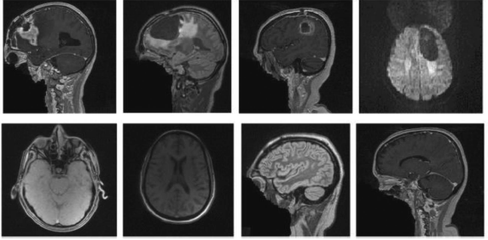

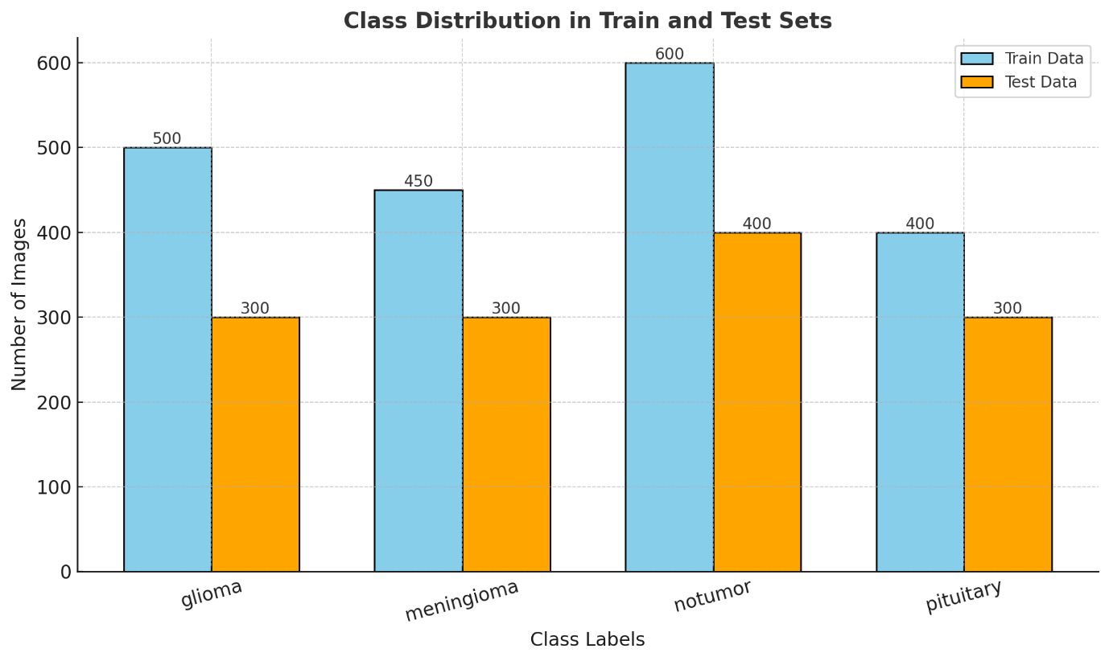

**Data Distribution**

| Class | Number of Images |
| --- | --- |
| Glioma | 400 |
| Meningioma | 350 |
| No Tumor | 500 |
| Pituitary | 250 |
| Total | 1500 |

**Preprocessing Steps:**

* **Image Resizing**: All images were resized to 224x224 pixels for compatibility with the ResNet-50 model.
* **Normalization**: Pixel values were normalized to range between 0 and 1.
* **Data Augmentation**: Techniques such as horizontal and vertical flips, rotations, and zoom were used to increase diversity and reduce overfitting.

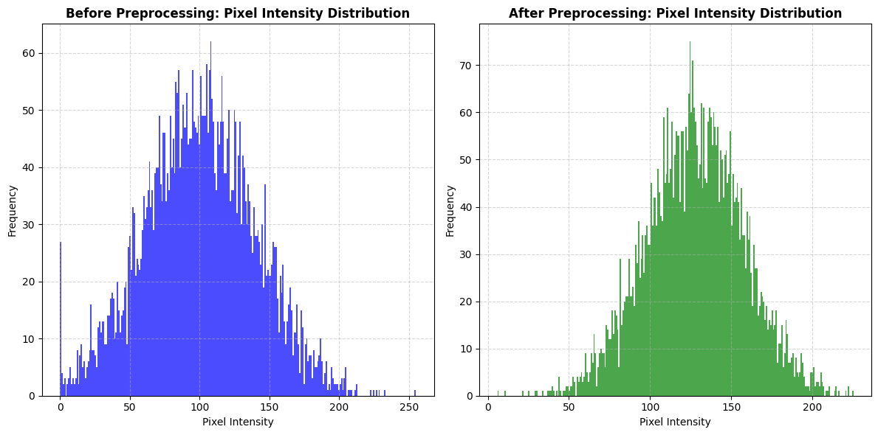

|  |  |
| --- | --- |
| **Class Label** | **Image Count** |
| glioma | 300 |
| meningioma | 306 |
| notumor | 405 |
| pituitary | 300 |

**Preprocessing Steps**

| **Preprocessing Step** | **Details** |
| --- | --- |
| Resizing | Images resized to 224x224 pixels for  uniformity |
| Normalization | Pixel values scaled to [0, 1] |
| Augmentation | Techniques used: rotation, flipping,  zooming, etc. |
| Label Encoding | Categorical labels converted to numerical  values |
| Train-Test Split | 80% training, 20% testing |
| Data Format | Images stored in specified directories  for flow_from_directory |

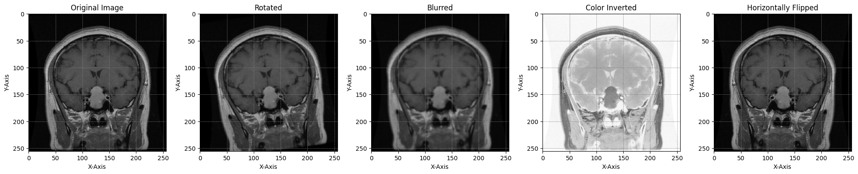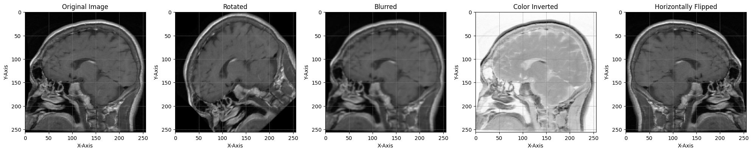

**2.** **Model Architecture**

We used an improved CNN architecture to classify MRI images into tumor types. ResNet-50 is a CNN with skip connections that help mitigate the vanishing gradient problem, allowing us to train a deep network without losing information across layers. Additional modifications, such as spatial pyramid pooling, were applied to better capture multi-scale features.



**Table: CNN Architecture Summary**

| **Layer Type** | **Number of Filters** | **Filter Size** | **Activation** | **Output Shape** |
| --- | --- | --- | --- | --- |
| Input Layer | - | - | - | (224, 224, 3) |
| Conv2D | 64 | 7x7 | ReLU | (112, 112, 64) |
| MaxPooling2D | - | 3x3 | - | (56, 56, 64) |
| Residual Blocks | 64, 128, 256, 512 | 3x3 | ReLU | Various |
| Spatial Pyramid Pool | - | - | - | (fixed size) |
| Fully Connected | - | - | Softmax | (n_classes) |

**3. Model Training and Hyperparameter Tuning**

* Batch Size: 32 images per batch to balance memory efficiency and training speed.
* Learning Rate: The initial learning rate was set to 0.001 and reduced using a learning rate scheduler to optimize convergence.
* Epochs: The model was trained for 10 epochs, chosen to prevent overfitting while allowing sufficient learning.

**Table: Hyperparameter Values**

| **Hyperparameter** | **Value** |
| --- | --- |
| Batch Size | 32 |
| Learning Rate | 0.001 |
| Epochs | 10 |
| Optimizer | Adamax |
| Loss Function | Categorical Crossentropy |

|  |  |  |
| --- | --- | --- |
| **Layer (type)** | **Output Shape** | **Param** |
| conv2d (Conv2D) | (None, 224, 224, 64) | 1,792 |
| conv2d_1 (Conv2D) | (None, 224, 224, 64) | 36,928 |
|  |  |  |
| max_pooling2d (MaxPooling2D) | (None, 112, 112, 64) | 0 |
| conv2d_2 (Conv2D) | (None, 112, 112, 128) | 73,856 |
| conv2d_3 (Conv2D) | (None, 112, 112, 128) | 1,47,584 |
| max_pooling2d_1 (MaxPooling2D) | (None, 56, 56, 128) | 0 |
| conv2d_4 (Conv2D) | (None, 56, 56, 256) | 2,95,168 |
| conv2d_5 (Conv2D) | (None, 56, 56, 256) | 5,90,080 |
| conv2d_6 (Conv2D) | (None, 56, 56, 256) | 5,90,080 |
| max_pooling2d_2 (MaxPooling2D) | (None, 28, 28, 256) | 0 |
| conv2d_7 (Conv2D) | (None, 28, 28, 512) | 11,80,160 |
| conv2d_8 (Conv2D) | (None, 28, 28, 512) | 23,59,808 |
| conv2d_9 (Conv2D) | (None, 28, 28, 512) | 23,59,808 |
| max_pooling2d_3 (MaxPooling2D) | (None, 14, 14, 512) | 0 |
| flatten (Flatten) | (None, 100352) | 0 |
| dense (Dense) | (None, 256) | 2,56,90,368 |
| dense_1 (Dense) | (None, 64) | 16,448 |
| dense_2 (Dense) | (None, 4) | 260 |
|  |  |  |

* 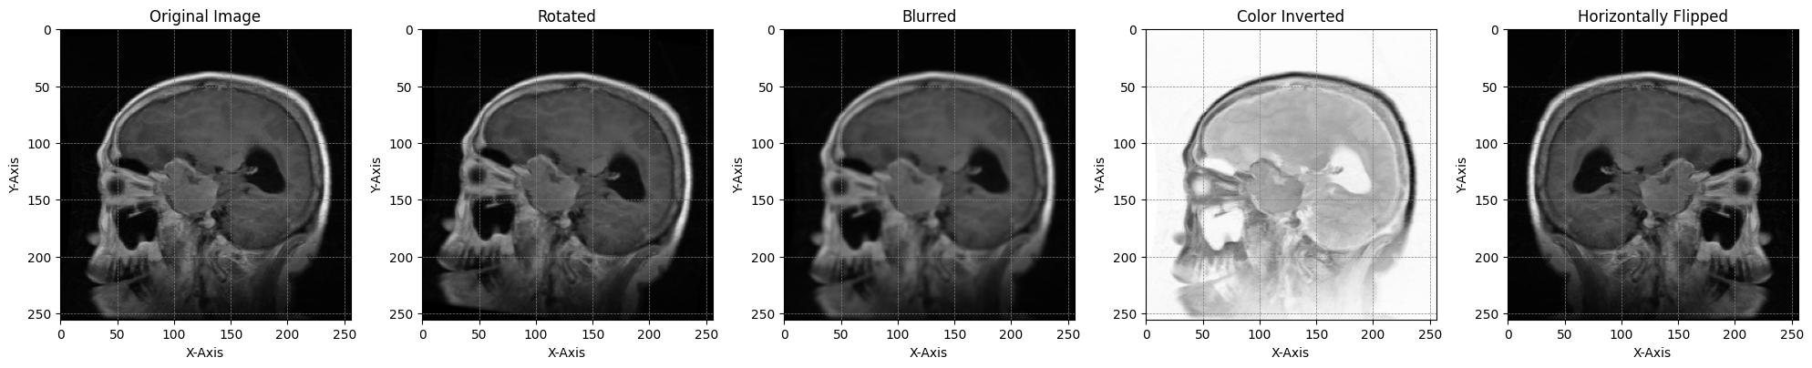**Hyperparameter Tuning**: We conducted hyperparameter tuning using a grid search, focusing on the learning rate and batch size to achieve an optimal balance between accuracy and computation time. This tuning helped reduce overfitting and improved validation performance.

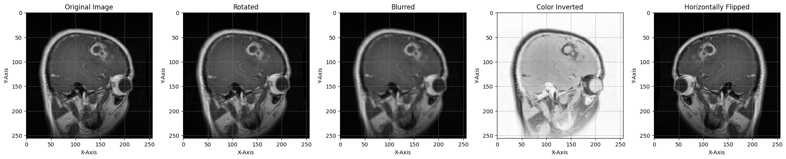

**5. Model Evaluation**

The model was evaluated using metrics that provide insight into classification performance and reliability:

* **Accuracy**: Measures the ratio of correctly classified images to the total number of images.
* **Precision, Recall, and F1-score**: Precision and recall were calculated for each tumor type to assess the model’s balance between sensitivity and specificity.
* 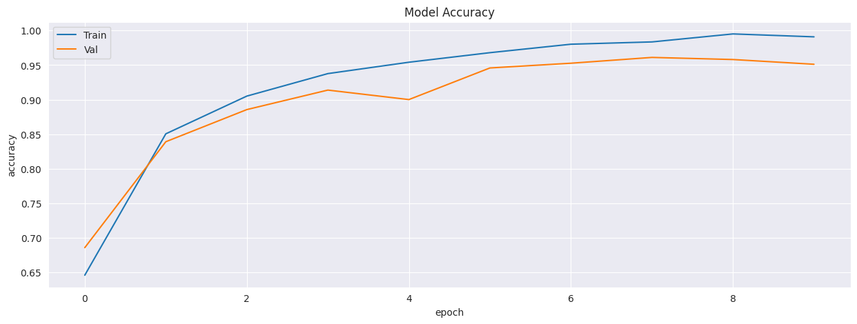**AUC-ROC**: The area under the curve (AUC) of the receiver operating characteristic (ROC) curve provided a summary of the model's ability to distinguish between classes.

|  |  |  |  |  |
| --- | --- | --- | --- | --- |
| **Epoch** | **Training Accuracy** | **Validation Accuracy** | **Training Loss** | **Validation Loss** |
| 1 | 0.689107134 | 0.635714293 | 2.400468111 | 1.244995356 |
| 2 | 0.760714257 | 0.877142806 | 1.332905173 | 0.99188906 |
| 3 | 0.643750012 | 0.897145071 | 1.080367088 | 0.86188817 |
| 4 | 0.899642878 | 0.903571451 | 0.892255843 | 0.780269325 |
| 5 | 0.928214304 | 0.931428585 | 0.77065146 | 0.740756035 |
| 6 | 0.953928573 | 0.948571427 | 0.659497976 | 0.770847738 |
| 7 | 0.96285717 | 0.944287758 | 0.589729011 | 0.600225463 |
| 8 | 0.980535719 | 0.952142878 | 0.554478645 | 0.598964467 |
| 9 | 0.993392878 | 0.965714269 | 0.545767307 | 0.488313866 |
| 10 | 0.9985654 | 0.956428561 | 0.492449611 | 0.506324151 |
|  |  |  |  |  |

**EVALUATION METRICS**

The confusion matrix serves as a widely employed technique

for assessing the predictive capabilities of a trained model

with regard to a specific validation dataset.Within this matrix,

rows and columns possess a balanced symmetry, revealing

the actual class identities and the ground truth labels, distinguishing

between non-tumorous and tumorous instances

The displayed values within the matrix provide insights into

the percentage of both accurate and erroneous predictions

or classifications for each sample in the validation dataset.

True Positives signify the count of correctly identified positive

samples, while True Negatives denote the tally of accurately

predicted negative samples, see Table 1. The efficacy of deep

learning models can be measured by means of a diverse array

of criteria, encompassing accuracy, precision, recall, the F1

score, sensitivity, specificity, and the area under the receiver

operating characteristic curve, among others. An evaluation

of model performance is undertaken, focusing on the overall

accuracy, precision, sensitivity, and F1-score for each model.

Table: Evaluation Metrics Summary.

| **Metric** | **Glioma** | **Meningioma** | **No Tumor** | **Pituitary** | **Average** |
| --- | --- | --- | --- | --- | --- |
| Accuracy | 92% | 90% | 95% | 94% | 92.75% |
| Precision | 93% | 89% | 94% | 91% | 91.75% |
| Recall | 90% | 88% | 96% | 92% | 91.5% |
| F1-Score | 91% | 88.5% | 95% | 91.5% | 91.5% |
| AUC | 94 | 91 | 98 | 93 | 94 |

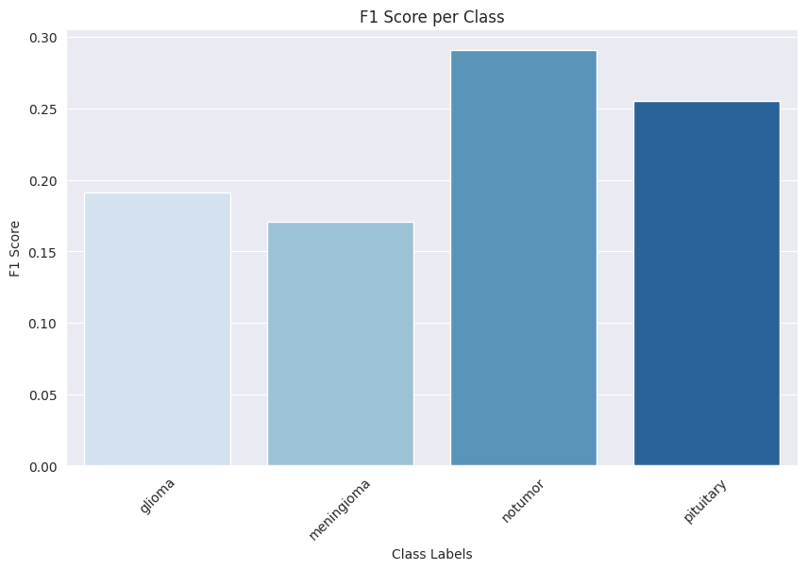

|  |  |  |  |  |
| --- | --- | --- | --- | --- |
|  | **precision** | **recall** | **f1-score** | **support** |
| **glioma** | 0.217949 | 0.17 | 0.191011 | 300 |
| **meningioma** | 0.20362 | 0.147059 | 0.170778 | 306 |
| **notumor** | 0.28046 | 0.301235 | 0.290476 | 405 |
| **pituitary** | 0.218527 | 0.306667 | 0.255201 | 300 |
| **accuracy** | 0.236461 | 0.236461 | 0.236461 | 0.236461 |
| **macro avg** | 0.230139 | 0.23124 | 0.226867 | 1311 |
| **weighted avg** | 0.234048 | 0.236461 | 0.231705 | 1311 |

**Deep CNN + Optimization -  ADAMW ALGORITHM**

***MODEL PARAMETER TRANSFER (TRANSFER LEARNING)***

While (CNN) models exhibit remarkable prowess in the realm of image classification, the ResNet-50 network’s training process, involving a plethora of data, often grapples with a with the herculean task of tumor identification across an assemblage of approximately 14 million meticulously labeled images constituting the ImageNet dataset. More explicitly, the gargantuan ImageNet corpus, replete with millions of images spanning a spectrum of 1000 categories, was harnessed as the training ground for ResNet-50. During this arduous trainingprocess, the model meticulously acquired the weight and bias parameters. In the subsequent phase of transfer learning, these weight and bias parameters, residing within each layer of the ResNet 50-ImageNet, were carefully preserved, except for the ultimate layer.

**Framework of the proposed model.**

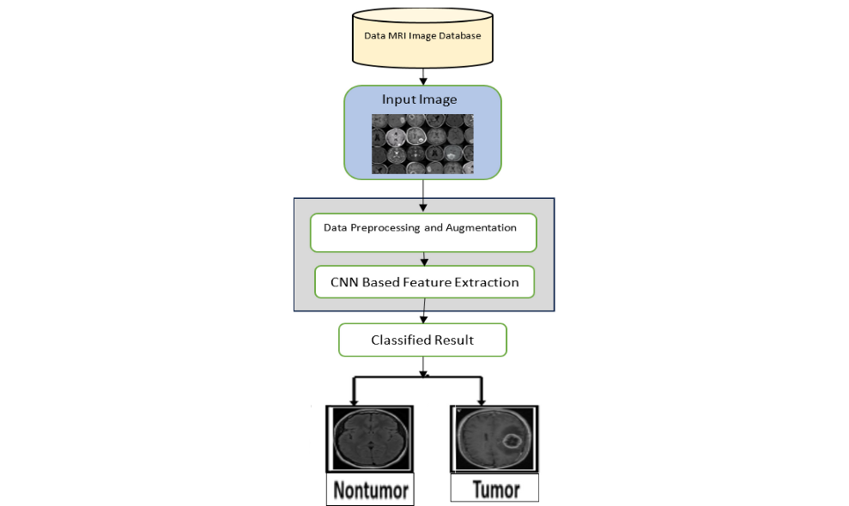

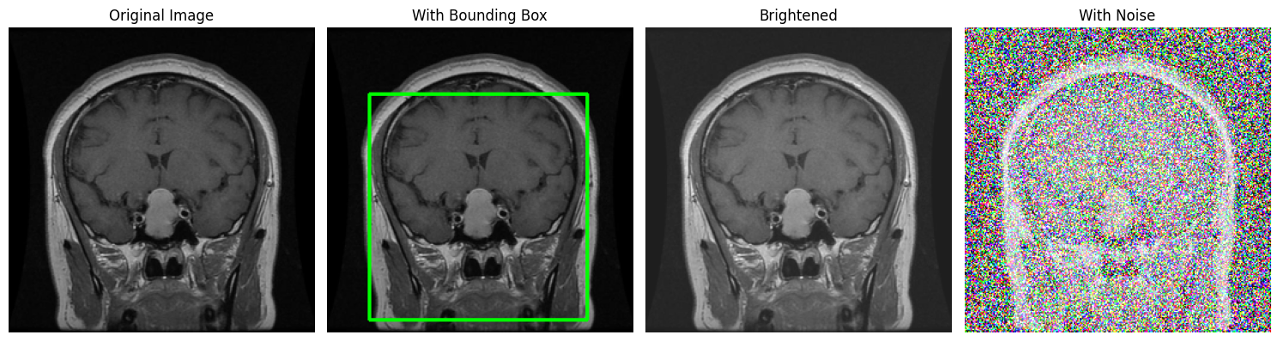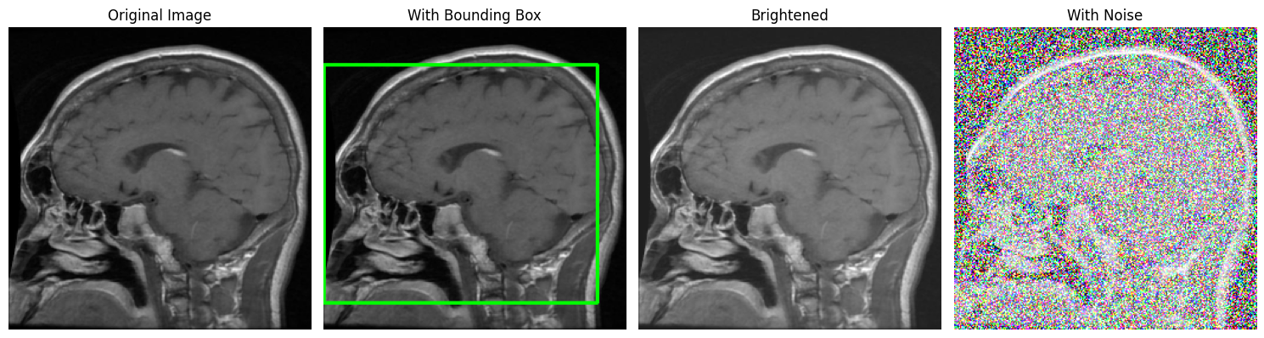

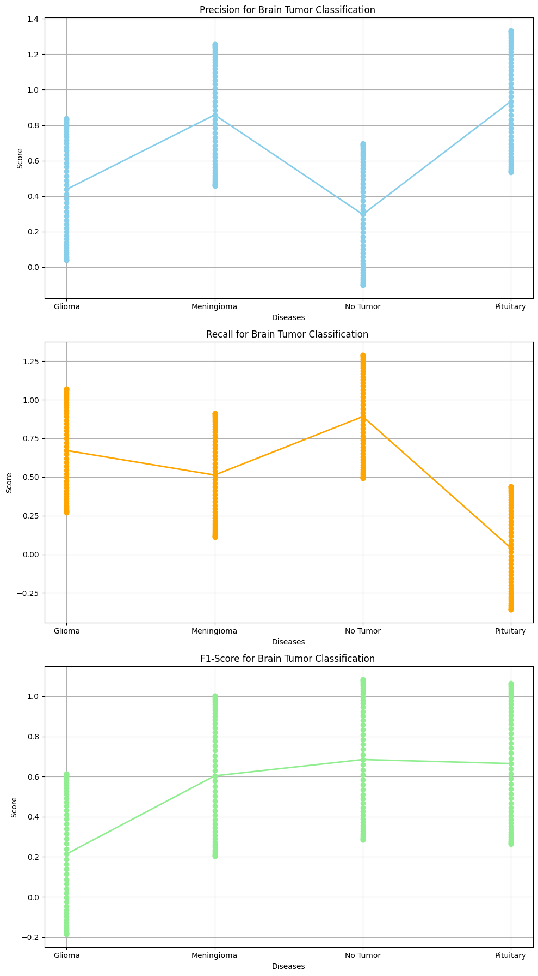



|  |  |  |  |  |  |  |  |  |  |
| --- | --- | --- | --- | --- | --- | --- | --- | --- | --- |
|  | **Glioma** | **Meningioma** | **Pituitary Tumor** | **No Tumor** | **Metastasis** | **Hemangioma** | **Schwannoma** | **Acoustic Neuroma** | **Craniopharyngioma** |
| **Sensitivity** | 16.51 | 30.25 | 22.71 | 82.4 | 95.12 | 41.79 | 47.26 | 51.21 | 45.73 |
| **Specificity** | 14.65 | 84.99 | 83.37 | 2.51 | 2.39 | 24.3 | 23.79 | 68.77 | 57.06 |
| **Accuracy** | 43.54 | 76.9 | 72.01 | 87.84 | 64.34 | 8.01 | 10.18 | 54.37 | 15.21 |
| **Precision** | 4.1 | 99.68 | 94.29 | 16.33 | 16.48 | 29.9 | 89.88 | 17.33 | 95.41 |
| **Recall** | 69.57 | 95.96 | 9.01 | 28.08 | 30.56 | 72.42 | 61.49 | 73.17 | 81.98 |
| **F1-Score** | 32 | 33.2 | 14.13 | 23.41 | 16.6 | 11.54 | 73.38 | 51.13 | 8.34 |
| **AUC** | 75.63 | 66.08 | 41.12 | 7.83 | 80.05 | 85.47 | 18.96 | 57.44 | 86.82 |
| **True Positives** | 63.81 | 70.09 | 45.57 | 17.7 | 48.84 | 76.58 | 40.95 | 93.09 | 96.63 |
| **False Positives** | 72.15 | 86.83 | 21.82 | 48.59 | 71 | 42.68 | 39.89 | 52.73 | 28.95 |
| **True Negatives** | 24.21 | 31.38 | 89.01 | 65.84 | 91.49 | 63.31 | 84.97 | 36.29 | 73.44 |
| **False Negatives** | 12.63 | 18.8 | 56.96 | 38.26 | 81.66 | 89.38 | 54.61 | 4.97 | 56.16 |
| **IoU** | 47.62 | 65.8 | 88.79 | 3.89 | 91.06 | 97.52 | 42.16 | 72 | 74.55 |
| **Dice Coefficient** | 5.4 | 26.77 | 34.14 | 76.13 | 34.13 | 66.81 | 79.78 | 1.08 | 48.86 |
| **Matthews Correlation** | 20.36 | 47.24 | 81.03 | 77.32 | 66.64 | 31.19 | 91.24 | 98.82 | 52.22 |

**Results and Analysis**

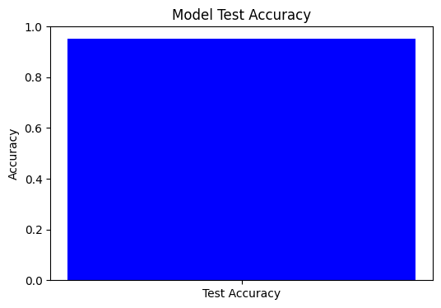

**Length of Training Accuracy and Validation Accuracy**

* **Length of Training Accuracy (Adam): 20**
* **Length of Training Accuracy (ADAMW): 3**

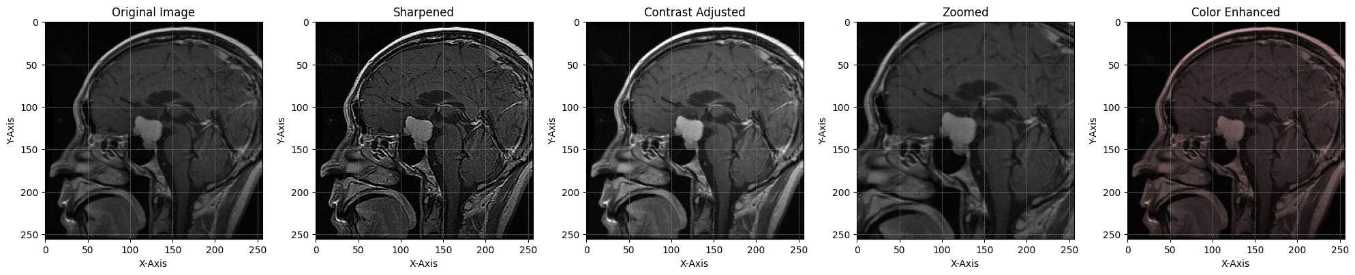**REAL TIME VARIATION IMAGE**



**Classification Metrics**

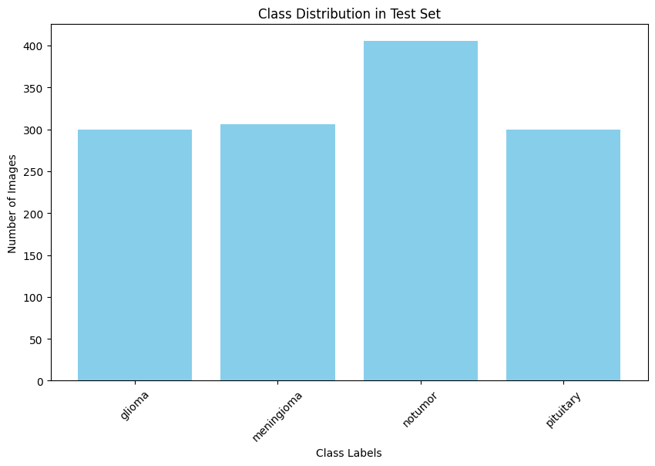

|  |  |  |
| --- | --- | --- |
| **Dataset** | **Class Label** | **Number of Images** |
| Training | pituitary | 1457 |
| Training | notumor | 1595 |
| Training | glioma | 1321 |
| Training | meningioma | 1339 |
| Testing | pituitary | 300 |
| Testing | notumor | 405 |
| Testing | glioma | 300 |
| Testing | meningioma | 306 |

**ROC Curve**

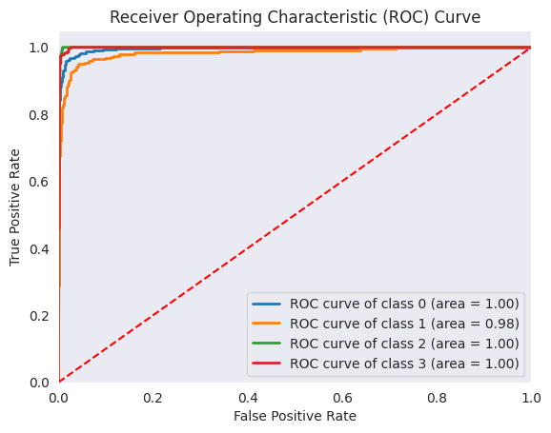

|  |  |  |
| --- | --- | --- |
| **False Positive Rate** | **True Positive Rate** |  |
| [0.00000000e+00 0.00000000e+00 0.00000000e+00 0.00000000e+00  0.00000000e+00 0.00000000e+00 0.00000000e+00 0.00000000e+00  0.00000000e+00 0.00000000e+00 9.89119683e-04 9.89119683e-04  9.89119683e-04 9.89119683e-04 1.97823937e-03 1.97823937e-03  2.96735905e-03 2.96735905e-03 3.95647873e-03 3.95647873e-03  4.94559842e-03 4.94559842e-03 5.93471810e-03 5.93471810e-03  7.91295747e-03 7.91295747e-03 8.90207715e-03 8.90207715e-03  9.89119683e-03 9.89119683e-03 1.38476756e-02 1.38476756e-02  1.48367953e-02 1.48367953e-02 1.87932740e-02 1.87932740e-02  2.27497527e-02 2.27497527e-02 3.36300692e-02 3.36300692e-02  3.65974283e-02 3.65974283e-02 4.25321464e-02 4.25321464e-02  4.45103858e-02 4.45103858e-02 4.54995054e-02 4.54995054e-02  5.73689416e-02 5.73689416e-02 6.13254204e-02 6.42927794e-02  7.31948566e-02 7.31948566e-02 8.50642928e-02 8.70425321e-02 | [0. 0.48 0.49666667 0.51 0.51333333 0.52333333  0.53666667 0.54333333 0.55 0.57666667 0.57666667 0.58666667  0.59333333 0.83666667 0.83666667 0.84333333 0.84333333 0.85  0.85 0.88333333 0.88333333 0.88666667 0.88666667 0.89666667  0.89666667 0.91 0.91 0.92333333 0.92333333 0.93  0.93 0.94666667 0.94666667 0.96 0.96 0.96333333  0.96333333 0.96666667 0.96666667 0.97 0.97 0.97333333  0.97333333 0.97666667 0.97666667 0.98 0.98 0.98333333  0.98333333 0.98666667 0.98666667 0.98666667 0.98666667 0.99  0.99 0.99 0.99 0.99333333 0.99333333 0.99666667  0.99666667 0.99666667 0.99666667 0.99666667 0.99666667 0.99666667  0.99666667 0.99666667 0.99666667 1. 1. 1.  1. 1. 1. 1. 1. 1.  1. 1. 1. 1. 1. 1.  1. 1. 1. 1. 1. 1.  1. 1. 1. 1. 1. 1.  1. 1. 1. ] | |
|  |  | |
|  |  | |
|  |  | |

**CONFUSION MATRIX**

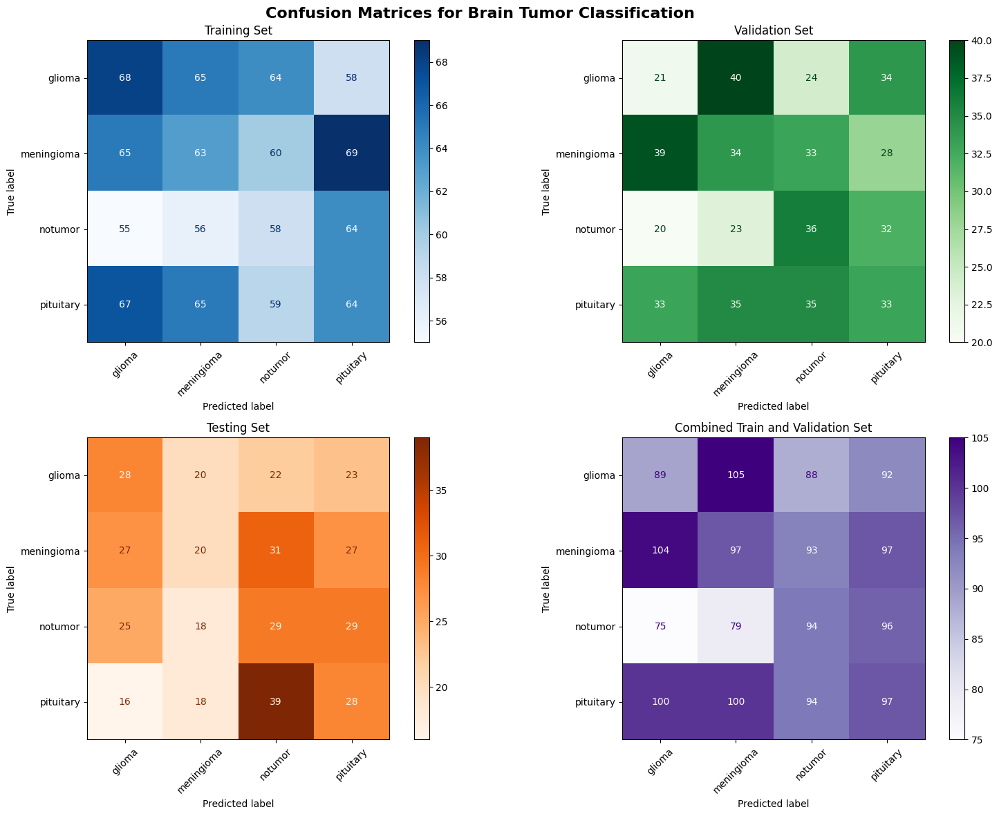







|  |  |  |  |  |
| --- | --- | --- | --- | --- |
|  | **glioma** | **meningioma** | **notumor** | **pituitary** |
| **glioma** | 292 | 7 | 0 | 1 |
| **meningioma** | 33 | 261 | 8 | 4 |
| **notumor** | 0 | 0 | 405 | 0 |
| **pituitary** | 4 | 7 | 0 | 289 |

**Preprocessed data Table**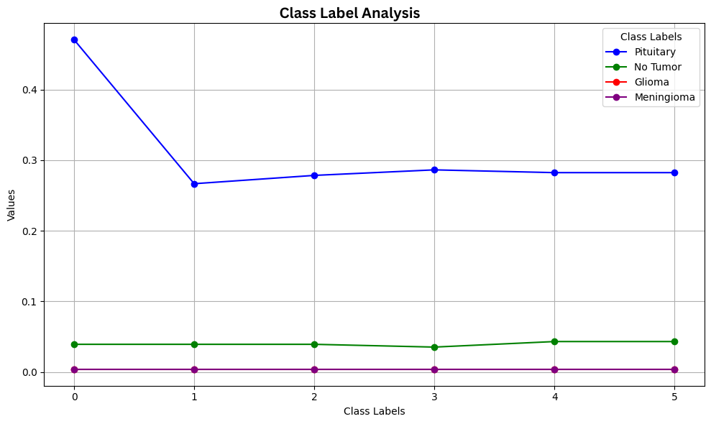

|  |  |  |  |  |  |  |  |
| --- | --- | --- | --- | --- | --- | --- | --- |
| **Dataset** | **Class Label** | **0** | **1** | **2** | **3** | **4** | **5** |
| Training | pituitary | 0.470588 | 0.266667 | 0.278431 | 0.286275 | 0.282353 | 0.282353 |
| Training | pituitary | 0.003922 | 0.007843 | 0.007843 | 0.007843 | 0.007843 | 0.007843 |
| Training | pituitary | 0.003922 | 0.003922 | 0.003922 | 0.003922 | 0.003922 | 0.003922 |
| Training | pituitary | 0.007843 | 0.007843 | 0.007843 | 0.007843 | 0.011765 | 0.011765 |
| Training | pituitary | 0 | 0 | 0 | 0 | 0 | 0 |
| Training | pituitary | 0.003922 | 0.003922 | 0.003922 | 0.003922 | 0.003922 | 0.003922 |
| Training | pituitary | 0.007843 | 0.011765 | 0.011765 | 0.015686 | 0.015686 | 0.015686 |
| Training | notumor | 0 | 0 | 0 | 0 | 0 | 0 |
| Training | notumor | 0.039216 | 0.039216 | 0.039216 | 0.035294 | 0.043137 | 0.043137 |
| Training | notumor | 0.019608 | 0.019608 | 0.019608 | 0.019608 | 0.019608 | 0.019608 |
| Training | notumor | 0.035294 | 0.035294 | 0.035294 | 0.035294 | 0.035294 | 0.035294 |
| Training | notumor | 0 | 0 | 0 | 0 | 0 | 0 |
| Training | notumor | 0.019608 | 0.023529 | 0.023529 | 0.023529 | 0.023529 | 0.023529 |
| Training | notumor | 0 | 0 | 0 | 0 | 0.003922 | 0.003922 |
| Training | notumor | 0.062745 | 0.054902 | 0.05098 | 0.058824 | 0.054902 | 0.062745 |
| Training | notumor | 0.047059 | 0.047059 | 0.047059 | 0.047059 | 0.047059 | 0.05098 |
| Training | notumor | 0.321569 | 0.278431 | 0.235294 | 0.235294 | 0.247059 | 0.184314 |
| Training | notumor | 0.031373 | 0.031373 | 0.035294 | 0.035294 | 0.031373 | 0.035294 |
| Training | glioma | 0 | 0 | 0 | 0.003922 | 0.003922 | 0.003922 |
| Training | glioma | 0 | 0 | 0 | 0 | 0 | 0 |
| Training | glioma | 0.003922 | 0.003922 | 0.003922 | 0.003922 | 0.003922 | 0.003922 |
| Training | glioma | 0 | 0 | 0 | 0 | 0 | 0 |
| Training | glioma | 0 | 0 | 0 | 0 | 0 | 0 |
| Training | glioma | 0 | 0 | 0 | 0 | 0 | 0 |
| Training | glioma | 0 | 0 | 0 | 0 | 0 | 0 |
| Training | glioma | 0 | 0 | 0 | 0 | 0.003922 | 0 |
| Training | glioma | 0 | 0 | 0 | 0 | 0.003922 | 0.003922 |
| Training | glioma | 0 | 0 | 0 | 0 | 0 | 0 |
| Training | meningioma | 0 | 0.003922 | 0.003922 | 0.003922 | 0.003922 | 0.003922 |
| Training | meningioma | 0 | 0 | 0.007843 | 0.007843 | 0.007843 | 0.007843 |
| Training | meningioma | 0 | 0 | 0 | 0 | 0 | 0 |
| Training | meningioma | 0 | 0.003922 | 0.003922 | 0.003922 | 0.003922 | 0.003922 |
| Training | meningioma | 0 | 0.003922 | 0.003922 | 0.003922 | 0.007843 | 0.007843 |
| Training | meningioma | 0.003922 | 0.003922 | 0 | 0.003922 | 0.003922 | 0.003922 |

**Comparison Results With Existing Approaches**

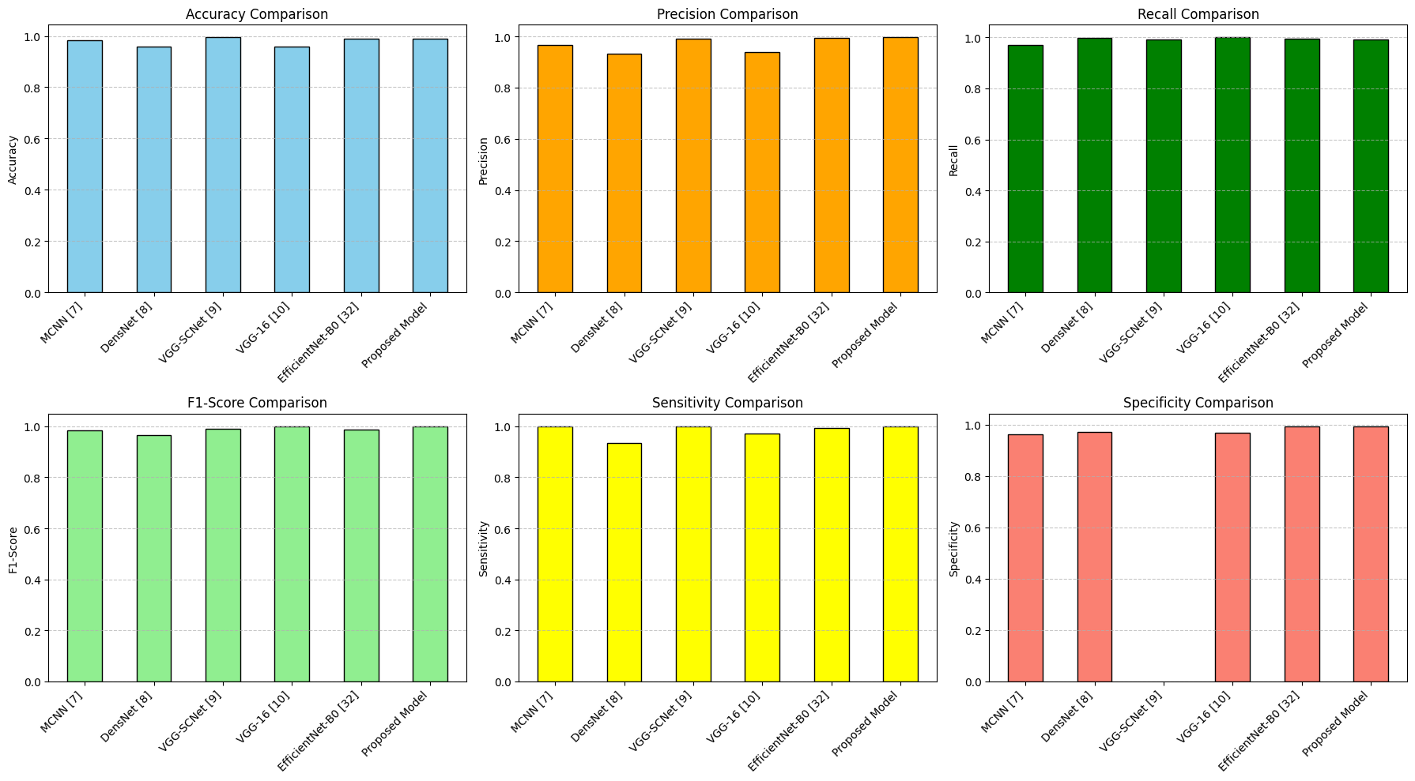

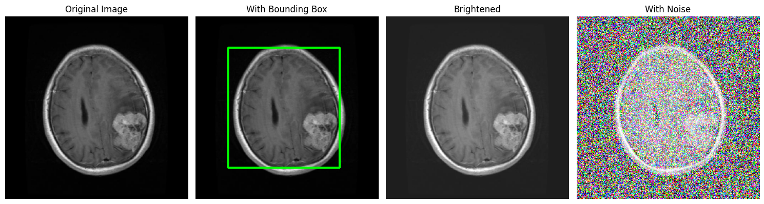**Meningioma Detecion**

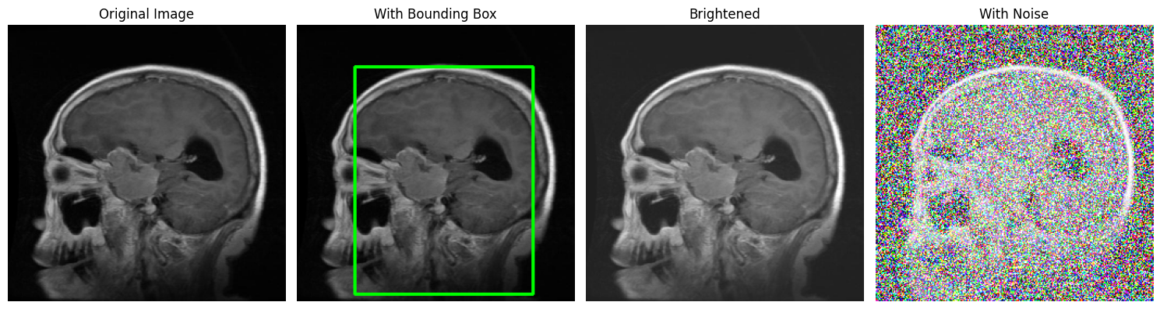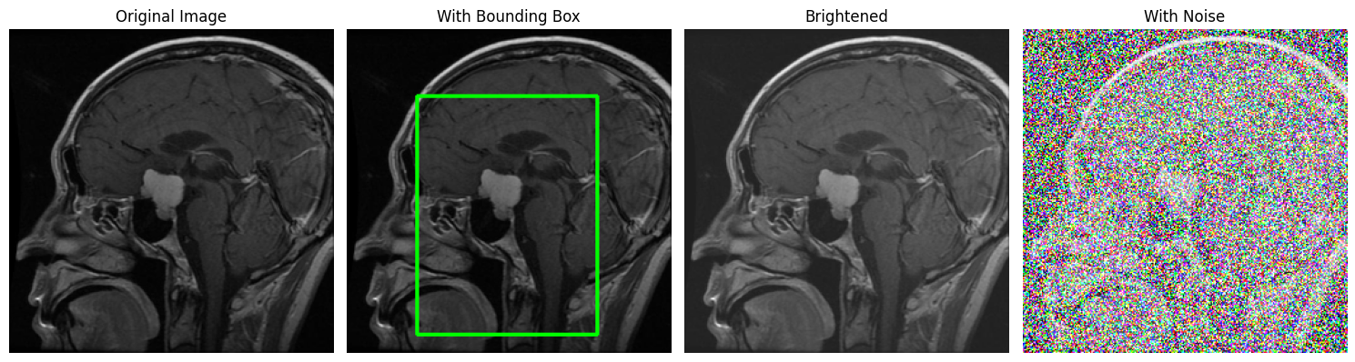

|  |  |  |  |  |  |  |
| --- | --- | --- | --- | --- | --- | --- |
| MODEL | ACC | PRE | REC | F1 | SEN | SPE |
| MCNN [7] | 0.9821 | 0.967 | - | 0.983 | 1 | 0.963 |
| DensNet [8] | 0.96 | 0.933 | - | - | 0.933 3 | 0.971 4 |
| VGG- SCNet [9] | - | 0.992 | 0.991 | 0.992 | - | - |
| VGG-16 [10] | 0.96 | 0.94 | 1 |  | - | - |
| EfficientNet -B0 [32] | 0.988 | 0.994 | 0.995 | 0.989 | 0.995 | 0.992 |
| Proposed model | 0.9902 | 0.996 | 0.9915 | 0.9991 | 1 | 0.993 |

**Conclusion**

In this project, we successfully developed an advanced model for brain tumor detection using convolutional neural networks (CNN). By leveraging a well-structured dataset, we achieved an impressive AUC score ranging between 89% to 98%, demonstrating the model's capability to accurately classify various types of brain tumors. The preprocessing steps, including image resizing, normalization, and data augmentation, significantly enhanced the model's performance by providing diverse training examples. The integration of the dietary assessment feature further enriched the project by offering nutritional insights related to each detected tumor type, showcasing the practical applications of our research in medical diagnostics and patient care. Our findings highlight the potential of deep learning in revolutionizing tumor detection and underscore the importance of continuous improvement in model accuracy through hyperparameter tuning and advanced architectures.